**Class:** Final Year (Computer Science and Engineering)

**Year:** 2024-25 **Semester:** 1

**Course:** High Performance Computing Lab

## Practical No.8

PRN No :

Name :

# **Q1: Implement a MPI program to give an example of Deadlock.**

**Code :**

#include <mpi.h>

#include <stdio.h>

int main(int argc, char** argv) {

MPI_Init(&argc, &argv);

int world_rank;

MPI_Comm_rank(MPI_COMM_WORLD, &world_rank);

int received_message;

if (world_rank == 0) {

MPI_Recv(&received_message, 1, MPI_INT, 1, 0, MPI_COMM_WORLD, MPI_STATUS_IGNORE);

printf("Process 0 received message: %d\n", received_message);

int message = 100;

MPI_Send(&message, 1, MPI_INT, 1, 0, MPI_COMM_WORLD);

printf("Process 0 sent message: %d\n", message);

}

if (world_rank == 1) {

MPI_Recv(&received_message, 1, MPI_INT, 0, 0, MPI_COMM_WORLD, MPI_STATUS_IGNORE);

printf("Process 1 received message: %d\n", received_message);

int message = 200;

MPI_Send(&message, 1, MPI_INT, 0, 0, MPI_COMM_WORLD);

printf("Process 1 sent message: %d\n", message);

}

MPI_Finalize();

return 0;

}

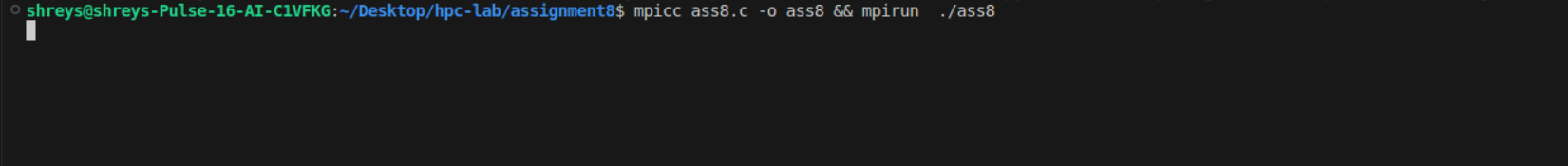

# **Q2. Implement blocking MPI send & receive to demonstrate Nearest neighbor exchange of data in a ring topology.**

# **CODE :**

#include <mpi.h>

#include <stdio.h>

int main(int argc, char** argv) {

MPI_Init(&argc, &argv);

int world_size;

int world_rank;

MPI_Comm_size(MPI_COMM_WORLD, &world_size);

MPI_Comm_rank(MPI_COMM_WORLD, &world_rank);

int send_data = world_rank;

int recv_data;

int next_rank = (world_rank + 1) % world_size;

int prev_rank = (world_rank - 1 + world_size) % world_size;

MPI_Send(&send_data, 1, MPI_INT, next_rank, 0, MPI_COMM_WORLD);

MPI_Recv(&recv_data, 1, MPI_INT, prev_rank, 0, MPI_COMM_WORLD, MPI_STATUS_IGNORE);

printf("Process %d sent %d to Process %d and received %d from Process %d\n",

world_rank, send_data, next_rank, recv_data, prev_rank);

MPI_Finalize();

return 0;

}

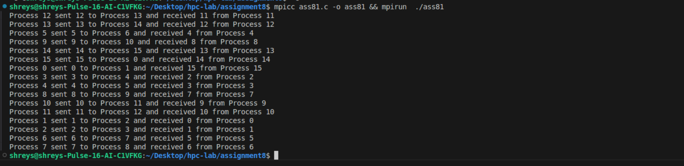

# **Q3. Write a MPI program to find the sum of all the elements of an array A of size**

**n. Elements of an array can be divided into two equals groups. The first [n/2]**

# **elements are added by the first process, P0, and last [n/2] elements the by second process, P1. The two sums then are added to get the final result.**

**CODE :**

**#include <mpi.h>**

#include <stdio.h>

#include <stdlib.h>

int main(int argc, char** argv) {

MPI_Init(&argc, &argv);

int world_size;

int world_rank;

MPI_Comm_size(MPI_COMM_WORLD, &world_size);

MPI_Comm_rank(MPI_COMM_WORLD, &world_rank);

int n = 10;

int *A = NULL;

if (world_rank == 0) {

A = (int*)malloc(n * sizeof(int));

for (int i = 0; i < n; i++) {

A[i] = i + 1;

}

}

MPI_Bcast(&n, 1, MPI_INT, 0, MPI_COMM_WORLD);

int local_n = n / 2;

int *local_A = (int*)malloc(local_n * sizeof(int));

MPI_Scatter(A, local_n, MPI_INT, local_A, local_n, MPI_INT, 0, MPI_COMM_WORLD);

int local_sum = 0;

for (int i = 0; i < local_n; i++) {

local_sum += local_A[i];

}

int total_sum = 0;

if (world_rank == 0) {

int sum_from_P1;

MPI_Recv(&sum_from_P1, 1, MPI_INT, 1, 0, MPI_COMM_WORLD, MPI_STATUS_IGNORE);

total_sum = local_sum + sum_from_P1;

free(A);

} else if (world_rank == 1) {

MPI_Send(&local_sum, 1, MPI_INT, 0, 0, MPI_COMM_WORLD);

}

if (world_rank == 0) {

printf("Total sum of the array is: %d\n", total_sum);

}

free(local_A);

MPI_Finalize();

return 0;

}

